MOSAIQ Image Review

1. Double-click the MOSAIQ RO icon on the desktop and log in.

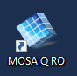

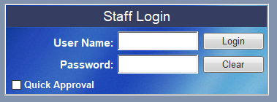

1. Open the patient.

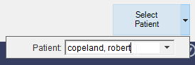

1. Click the **Image Review** icon at the top of the screen.

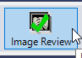

1. Click each image thumbnail at the top of the window.

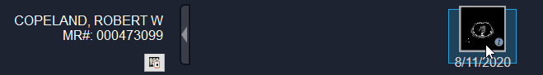

Scroll through the three views and click the green checkmark to approve the image.



Click the **Save** button.



1. Exit the **Image Review** window by clicking the down arrow in the top right corner and choosing **Undock**.

